**< WEEKLY REPORT FOR WEEK 6 >**

Name: Oh SuJin

Project: Multimodal Sensor Interfacing, Acquisition and Visualization

**I) Project Work Summary**

**Finished:**

* Research on similar project, YouGrabber, and discussion with Visualization team how to improve those common shortcomings of existing rehab application like YouGrabber and successfully implement the solutions for iFarm.
* iFarm application flow

**Ongoing:**

* Java-Unity integration and communication protocol.

**II) Tasks Assigned**

**III) Detailed Activities / Accomplishments**

**DAY1**

* Research and summarization on AllJoyn, which allows users to create dynamic proximal networks by enabling ad hoc, proximity based, peer-to-peer networking between devices and application.
* Its applicability to iFarm.

**DAY2&3**

* Research on similar project, YouGrabber.
* YouGrabber developed by Swiss startup YouRehab consists of a pair of therapy-optimized data gloves with integrated movement tracking, providing interactive therapy exercises which focus on visuo-motor finger, hand and arm coordination. This enables training for bimanual reaching and grabbing.

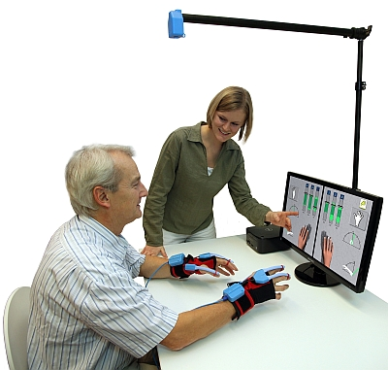

* However this exercise application provides relatively simple grabbing and stretching rehab programme which can be boring leading to poor compliance.
* Furthermore YouGrabber involves hassles of wearing motion tracking sensors.
* iFarm therefore aims to overcome these common shortcomings of existing system.
* One of solutions is providing 3D visualization of hand and ADL exercises (will be explained later)
* Discussion with visualization team is followed.

**DAY 4 & 5**

* Draw application flow of iFarm
* Once exercise is selected and patient is ready to start exercise, user’s hand tracking information will be collected at DAQ unit from Leap Motion, which will be soon processed by Feature Extraction unit where necessary data features are selected and passed over to the next unit. Assessment unit will then identify whether the exercise is done correctly or not and how many repetitions user has done, notifying 3D Unity and the Arduino IDE its exercise progress. At last, respective visual, audio and even haptic feedback message will be sent through the 3D unity UI and the Arduino-controlled wristband.

